INDIVIDUAL ASSIGNMEENT ON HANDOUT RFM ANALYSIS 100 POINTS
PREFERABLY USE SEVERAL BULLET POINTS IN YOUR RESPONSES FOR THESE QUESTIONS. SHOW CALCULATIONS AND GRAPHS AS NECESSARY
1) Direct marketing response rates could be very low. Successful, profitable promotions often result from sales to 2% or less of the mailed universe. However, database marketers now regularly apply a successive sorting algorithm (RFM) to code the customer identifiers in order to hone their effort in terms of RoCI (Return on Campaign Investment). Application of Independent sorting algorithm on each of the attributes could typically give you the results as shown in the graphs below:

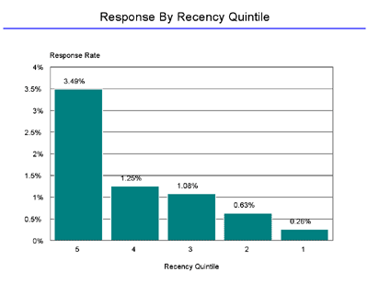
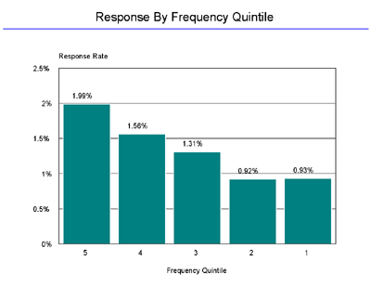
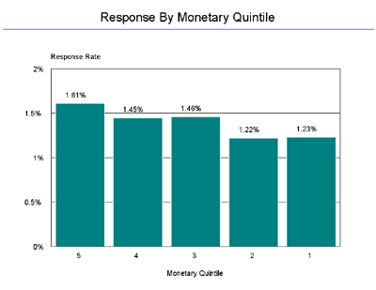

1) Rank the attributes in order of their discriminating ability. Does a higher discriminating ability of any of the above attributes necessarily mean a better set of decision for you? (Several bullet points). 20 points
2) Explain how you will actually perform a RFM analysis with the above quintile-based sorting algorithm. Use a diagram to show creation of cells/blocks from 111 through 555 (5>4>3>2>1). 25 points
3) Total how many distinct cells/blocks will you have? If you have 1 million customers, how many are you likely to have in every cell/block? Do you need any further information before you can finalize your campaign initiatives (even after you have these cells separated out through your RFM analysis)? 20 points.
4) How can you use the reach-richness compromise paradigm to further optimize your campaign? Provide a real life example with multichannel CRM approach. 10 points.

5) There are 4 components of DSS that use the data marts and data warehouse, viz., Data Store, Data Extraction and Filtering, End user query tool and End user presentation tool. Search the internet and create a 4 column table where each of these 4 components are represented in a column and provide 1 row each for 2 top products for each of the 4 components in the market and 3 Main features of each product. 25 points

